**Generalizable Pest and Pathogen Model User’s Manual**

Version 1.0

Authors:

Chris Jones

Yu Takeuchi

Glenn Fowler

Vaclav Petras

Helena Mitosova

Ross Meentemeyer

Contents

Version Updates 2

Version 1.0: Original Version 2

Model 3

Parameters 4

Pest/Pathogen 4

Species Name 4

Start Year 4

End Year 4

Does seasonality affect spread? 4

Spread Rate 4

Initial Infection Data: 4

Dispersal Kernel 4

Host 4

Is the system single- or multi-host? 4

Number of host species 5

Host Data 5

Host Index Score 5

Total Species Data 5

Environmental Effects 5

Does wind affect spread? 5

Wind data type 5

Predominate wind direction 5

Kappa: 5

Does temperature affect spread 6

Temperature Data 6

Does precipitation affect spread 7

Precipitation Data 7

References 8

# Version Updates

## Version 1.0: Original Version

First release of the model and GUI for pest and pathogen modeling.

# Model

# Parameters

The model uses species reproduction

## Pest/Pathogen

### Species Name

The name of the pest or pathogen of interest. Currently, this is only used for plotting. In the future this can link to a database to suggest the best-known parameters for the species.

### Start Year

The year to start the simulation. This can be the first year of detected infection or the year that the user wants the simulation to start from.

### End Year

The final year to predict spread. This is how far into the future to predict the spread of the pest or pathogen of interest.

### Does seasonality affect spread?

Can spread only occur during certain times of the year due to environmental or life history constraints. If no all months are used to calculate spread. This parameter is used to reduce computational time and/or limit spread if good environmental data is unavailable for the location of interest.

### Spread Rate

Spread rate is defined as the number of new individual that spread from a single infected individual at a given time step. In epidemiology this is known as R0, the average number of susceptible individuals infected by a single infected individual in a time step. (Note: this is one of the most sensitive parameters in the model. If too high you will overestimate spread and if too low very little spread will occur)

### Initial Infection Data:

This is a raster file of the locations of infection/infestation for the year of simulation start (Start Year). In the future this will also accept shapefile or .csv locations.

### Dispersal Kernel

Choose from one of 4 types of dispersal kernel that best fits your pest/pathogens spread pattern.

## Host

### Is the system single- or multi-host?

Does your pest or pathogen have multiple hosts or a single host that it is capable of reproducing and spreading from? A single-host system only has one host species. If all host species are equally preferred (competent) then the user can choose to treat all hosts as a single host if uninterested in number of infected hosts by species. If multi-host is selected then the user is asked to select the number of hosts (up to 10) that contribute to spread and given an input box for host data (a raster of host density) and host score for each host species.

### Number of host species

The number of host species that contribute to spread. Species that contribute to spread equally can be aggregated together if the user is not interested in the number of trees of that species. Host Data and Host Index Score for a species grouped together with Host Data above Host Index Score.

### Host Data

A raster file of the host species density. Used as the absolute density.

### Host Index Score

A numeric value (0 to 10) for the effect of the species on spread. This controls for the preference of the pest for certain species and the effect of host competency on inoculum production. It is the ability of the host to contribute to spread. A score of 10 means that the species contributes highly to spread while a value of 0 means that the species doesn’t contribute to spread. A value of 0 is used if the pest/pathogen doesn’t contribute to spread but is affected by the pest/pathogen and the user wants to track infections in that species. A value of 5 contributes to spread at 50% of the rate of a value of 10. Example: *Phytophthora ramorum*, the casual agent of sudden oak death, Oaks experience mortality from the disease but don’t contribute to

### Total Species Data

A raster file of all the density of all trees for the location of interest. This is used to control of increased difficulty of finding a host when hosts are not abundant.

## Environmental Effects

### Does wind affect spread?

If wind affects the spread of the pest or pathogen of interest and predominate wind direction is available select yes. If not select no. Selecting yes requires the selection of 3 other parameters (Wind data type, predominate wind direction, and Kappa).

### Wind data type

Currently the only selectable option is direction. Future versions will allow polygon shapefiles and/or raster inputs of wind direction in order to account for variation across larger spatial scales.

### Predominate wind direction

What is the predominate wind direction selectable in 45° increments (NE, E, SE, S, SW, W, NW, N). This sets the predominate direction that spread will occur.

### Kappa:

Kappa controls the dispersal direction dominance set by predominate wind direction for the von Mises distribution. This controls how much effect wind plays in dispersal of the pest or pathogen. Kappa = 0 means that dispersal is equally likely in all directions (no effect of wind direction). Kappa = 8 much more likely to disperse in the direction of the wind.

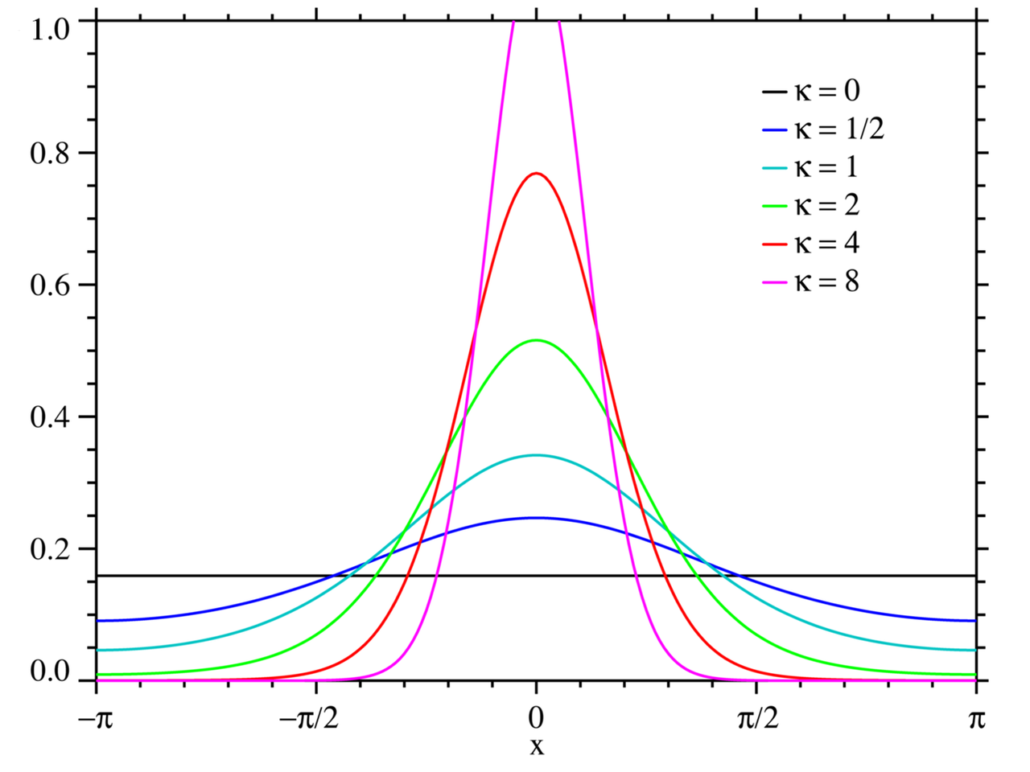

Von Mises distribution probability density function for various levels of kappa (image from [Wikipedia](https://en.wikipedia.org/wiki/Von_Mises_distribution)).

### Does temperature affect spread

Does temperature affect the ability of the pest/pathogen to reproduce and/or spread and do you have temperature data for your study area? If the answer to both of these questions is yes select yes if not select no. If yes, another variable (Temperature Data) becomes available. Future versions will include options for functions based on the effect of temperature on spread as another parameter.

### Temperature Data

Input a NetCDF file of temperature data for the location and time period you are interested in. Currently data is aggregated to weekly inputs for the model based on a function for the effect of temperature. Future version will make inputs daily but run a function to aggregate them to the timestep chosen by the user.

### Does precipitation affect spread

Does precipitation affect the ability of the pest/pathogen to reproduce and/or spread and do you have precipitation data for your study area? If the answer to both of these questions is yes select yes if not select no. If yes, another variable (Precipitation Data) becomes available. Future versions will include options for functions based on the effect of precipitation on spread as another parameter.

### Precipitation Data

Input a NetCDF file of precipitation data for the location and time period you are interested in. Currently data is aggregated to weekly inputs for the model based on a function for the effect of precipitation. Future version will make inputs daily but run a function to aggregate them to the timestep chosen by the user.

# References